**THE ROLE OF SCHOOL COUNSELOR**



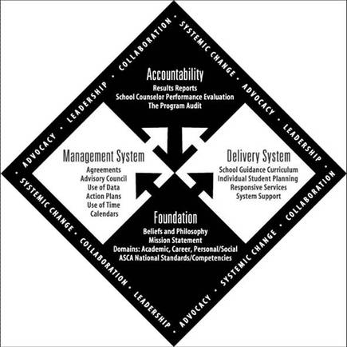

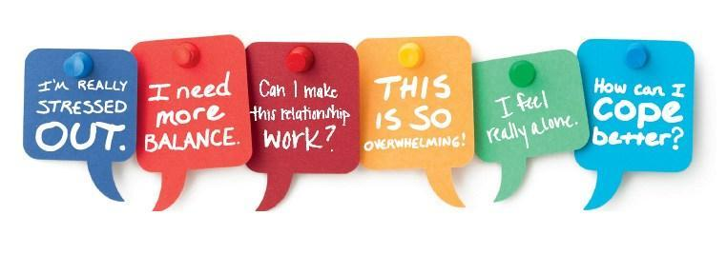

**ETHICAL STANDARDS FOR SCHOOL COUNSELORS**

School counselors are advocates, leaders, collaborators, and consultants who seek to bring about systemic change by aligning their school counseling programs with the district's vision and improvement goals in order to ensure that all students have equitable access to and success in school. School counselors exhibit their belief that all students have the ability to learn by pushing for an education system that provides optimal learning environments for all children.*All students have the right to:*

Respect, dignity, and access to a comprehensive school counseling program that advocates for and affirms all students from diverse populations, including but not limited to: ethnic/racial identity, nationality, age, social class, economic status, abilities/disabilities, language, immigration status, sexual orientation, gender, gender identity/expression, family type, religious/spiritual identity, emancipated minors, wards of the state, homeless youth.

Receive important, current information on college, career, and postsecondary possibilities, as well as a thorough understanding of how college and career readiness might influence their educational choices and future opportunities.

While balancing other competing interests (e.g., best interests of children, safety of others, parental rights) and according to laws, rules, and ethical standards relevant to confidentiality and disclosure in the school setting, privacy should be respected to the greatest extent practicable.

Abuse, bullying, harassment, and other types of violence are prohibited in a safe school environment that promotes autonomy and justice.

**RESPONSIBILITY TO STUDENTS**



**1. Supporting Student Development**

***School counselors:***

* Have a primary responsibility to the pupils, who must be treated as distinct persons with dignity and respect.
* Aim to give students with short-term therapy and to assist students, families, and guardians in getting outside services if the student requires long-term clinical counseling.
* Do not diagnose, but be mindful of how a student's condition may impair his or her academic progress.
* Recognize the importance of parents, guardians, and families.
* Are interested about students' academic, career, and social/emotional needs, and promote each student's full potential.
* Respect students' and families' values, beliefs, sexual orientation, gender identity/expression, and cultural background, and avoid imposing personal ideas or values based on religion, culture, or ethnicity.
* Maintain proper limits and be aware that any sexual or romantic contact with students, whether legal or illegal in the state of practice, is a grave breach of ethics and is banned regardless of the age of the student.



**2. Confidentiality**

***School counselors:***

* Promote understanding of school counselors' ethical standards and legal obligations in terms of confidentiality, as well as the proper rationale and procedures for disclosing student data and information to school staff.
* Multiple techniques, such as student handbooks, school counselor department websites, school counseling pamphlets, classroom teachings, and/or verbal notice to individual students, can be used to explain the boundaries of confidentiality in developmentally appropriate terms.
* Protect the privacy of students' records and distribute personal information in line with federal and state laws as well as school board policy.

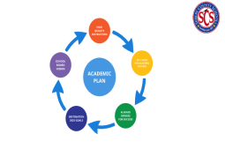

**3. Academic, Career and Social/Emotional Plans**

***School counselors:***

* Create a culture of postsecondary readiness in collaboration with administration, teachers, staff, and decision-makers.
* Provide and advocate for individual students' prekindergarten–postsecondary college and career awareness, exploration, and postsecondary planning and decision-making, which promotes students' right to choose from a wide range of possibilities when they finish secondary school.
* Identify college and job access gaps, as well as the significance of this information for addressing both intentional and inadvertent biases in college and career advising.



**4. Group Work**

***School counselors:***

* Facilitate short-term groups to address academic, professional, and/or social/emotional challenges that students are facing.
* Notify parents/guardians about their child's participation in a small group.
* Students are screened for group membership. d. Analyze data to determine member needs and set clear expectations for group members.
* Select group themes with the understanding that some topics are inappropriate for school groups, and take appropriate safeguards to protect members from damage as a result of group interactions.
* Facilitate groups using evidence-based or research-based techniques as a framework.
* Follow up with the members of the group as needed.

***School counselors:***

**5. Student Peer-Support Program**

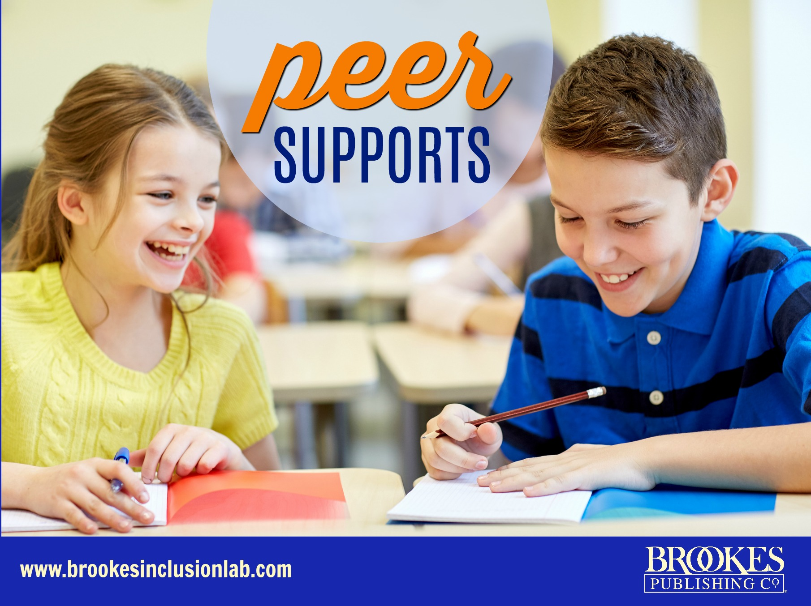

Supervise students who are involved in peer-to-peer assistance, mediation, or other peer-to-peer support groups. In school counseling programs, school counselors are accountable for the appropriate skill development of students who serve as peer support. Students who provide peer assistance are constantly monitored by school counselors, who emphasize the confidential nature of their work. Peer-support kids are informed about the parameters of when they must report information to responsible adults by school counselors.

**6. Serious and Foreseeable Harm to Self and Others**



***School counselors:***

* When a student poses a substantial and predictable danger of injury to self or others, notify parents/guardians and/or authorized authorities. When possible, this should be done after thorough consideration and consultation with other experts. Students are informed of the school counselor's legal and ethical responsibility to report the concern to the relevant authorities unless withholding this information is necessary to safeguard the student (e.g., if the kid knows his or her parents are being called, he or she may flee). The risk of not giving parents/guardians an opportunity to intercede on their child's behalf is just too great.
* Do not discharge a student who poses a risk to himself or others until he or she has received the appropriate and required support. If parents refuse to give adequate support, the school counselor takes the necessary steps to remind parents/guardians of the importance of seeking help, which may include filing a report with child protective services.
* When students disclose a perpetrated or perceived threat to their bodily or mental well-being, report it to their parents/guardians and/or proper authorities. Physical abuse, sexual abuse, neglect, dating violence, bullying, and sexual harassment are all examples of threats.



**7. Student Records**

***School counselors:***

* Follow the Family Educational Rights and Privacy Act (FERPA), which establishes who has access to a student's educational records and gives parents the opportunity to inspect and challenge any mistakes.
* b. Defend the ethical use of student data and records, and alert administrators to any improper or detrimental practices.
* b. Recognize the difficulty of achieving sole-possession record standards.

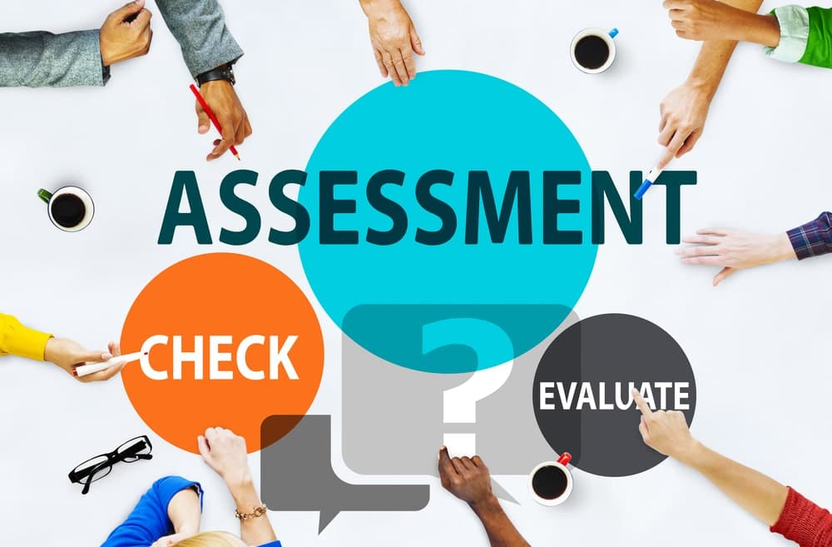

**8. Evaluation, Assessment and Interpretation**

***School counselors:***

* Defend the ethical use of student data and records, and alert administrators to any improper or detrimental practices.
* Recognize the difficulty of achieving sole-possession record standards.



**9. Virtual/Distance School Counselling**

***School counselors:***

* In a virtual/distance context, follow the same ethical requirements as school counselors in face-to-face settings.
* Recognize the challenges and limitations of virtual/distance school counseling and accept them.
* Explain the benefits and drawbacks of virtual/distance counseling to both the student and the parent/guardian.
* Teach students how to participate in the electronic school counseling relationship in order to reduce and prevent potential misunderstandings caused by a lack of verbal cues and an inability to read body language or other visual cues that provide context to the school counseling process and relationship.



**RESPONSIBILITY TO PARENTS/GUARDIANS,SCHOOL AND SELF**

**1. Responsibilities to Parents/Guardians**

***School counselors:***

* Respect the rights and duties of both custodial and noncustodial parents/guardians, and, if needed, form a collaborative relationship with them to help students reach their full potential.
* Inform parents about the school counseling program's mission and program standards in the academic, career, and social/emotional domains that encourage and enhance all students' development.
* Explain to parents/guardians that the school counseling relationship between the school counselor and the student is confidential.



**2. Responsibilities to the School**

***School counselors:***

* To help children, develop and maintain professional connections and communication channels with school personnel, employees, and administrators.
* Develop and implement comprehensive school counseling programs that are related to the academic mission of the school, are driven by student data, are based on academic, career, and social/emotional development standards, and encourage and enhance the learning process for all students.
* Collaborate with appropriate officials to remove any obstacles that may be impeding the school's or school counseling program's effectiveness.
* When the school counselor's role allows it, provide support, consultation, and mentoring to professionals in need.
* Advocate for administrators to hire licensed school counselors who are competent, qualified, and have a master's degree or higher in school counseling from an accredited institution in school counseling roles.

***School counselors:***



**3. Responsibilities Self**

* Have acquired a master's degree in school counseling after completing a counselor education program at a recognized university.
* Accept jobs only if they are qualified for them based on their degree, training, and supervised experience.
* To be an effective culturally competent school counselor, keep track of and enhance your personal multicultural and social-justice advocacy awareness, knowledge, and abilities. Understand how prejudice, privilege, and various forms of oppression affect students and stakeholders based on ethnicity, racial identity, age, economic status, abilities/disabilities, language, immigration status, sexual orientation, gender, gender identity expression, family type, religious/spiritual identity, appearance, and living situations (e.g., foster care, homelessness, incarceration).



**SCHOOL COUNSELOR ADMINISTRATORS/SUPERVISORS**

***School counselor administrators/supervisors support school counselors in their charge by:***

* Advocating for a more equitable and open distribution of resources among supervised programs. A non-discriminatory, data-driven, and consistently applied allocation mechanism should be designed.
* Taking reasonable steps to ensure that enough school and other resources are available for staff supervision and training.



**MAKE ETHICAL DECISION**

School counselors and school counseling program directors/supervisors employ an ethical decision-making paradigm like Solutions to Ethical Problems in Schools when they are faced with an ethical challenge.

* Emotionally and intellectually define the situation.
* Follow the law and the ASCA Ethical Standards for School Counselors.
* Take into account the students' ages and developmental stages.
* Take into account the situation, parental rights, and minors' rights.
* Use the ethical concepts of beneficence, autonomy, nonmaleficence, loyalty, and fairness to guide your actions.
* Determine possible courses of action and their ramifications.
* Assess the chosen action.
* Seek advice.
* Carry out the plan of action.