**POLICE EMERGENCY**

**LOCAL RESOURCES**

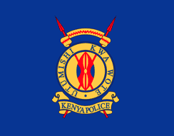

**CORE FUNCTIONS**

* Maintenance of law and order;
* Preservation of peace;
* Protection of life and property;
* Prevention and detection of crime;
* Apprehension of offenders; and
* Enforcement of all laws and regulations with which it has been charged.

Office of the Inspector General  
Taifa Road, Jogoo House "A" 4th Floor  
P.O Box 44249-00100 Nairobi, Kenya  
Telegraphic address: "IG,NPS"  
Tel:+254 20 2221969  
Website: [www.nationalpolice.go.ke](http://www.nationalpolice.go.ke/)

Mail: [nps@nationalpolice.go.ke](mailto:nps@nationalpolice.go.ke)

[Police Hot Lines - 999 / 112 / 911](https://www.nationalpolice.go.ke/)

**INFORMATION**

**HOTLINE**

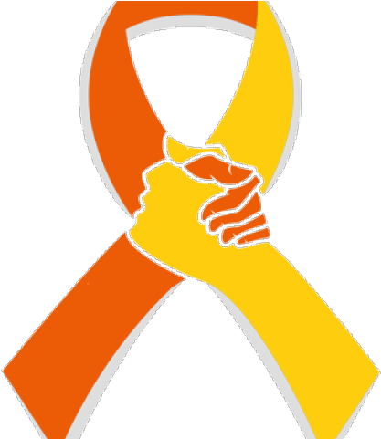

**SUICIDE HOTLINE**

Suicide prevention and crisis helpline is a free, nationwide service available to everyone and is operated by highly trained and experienced telephone counselors who have undergone advanced suicide prevention training.

0800723253

La Colline Gardens, Masaba road off Bunyala road,

Upperhill. Plot No.10, Block 2, Flat 12

Helpline: +254 722 178 177

befrienderskenya@gmail.com

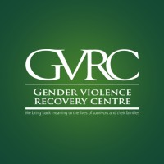 

**GENDER VIOLENCE RECOVERY CENTRE (GVRC)**

GVRC’s main pur­pose is to bring back mean­ing to survivor’s lives and their fam­i­lies. We do this through the pro­vi­sion of free med­ical treat­ment and psy­choso­cial sup­port to sur­vivors of gen­der based vio­lence. The med­ical sup­port given is the basic treat­ment for sur­vivors of Gen­der Based Vio­lence (GBV) that includes emo­tional, phys­i­cal, sex­ual and psy­cho­log­i­cal abuse.

Mobile Number: 0709667000

Address: Block B, Kirichwa Road, Opp Adams Arcade, Off Ngong Road  
P.O. Box 10552-00100  
Nairobi, Kenya

Kenyatta National Hospital GVRC  
Mobile Number: 0719638006

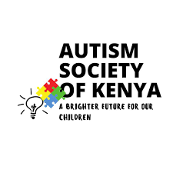

**AUTISM SOCIETY OF KENYA**

**(ORGANIZATIONS OFFERING**

**SERVICES FOR THE DISABLED)**

Autism spectrum disorder (ASD) is a general term for a group of complex disorders of brain development. These disorders are characterized, in varying degrees, by difficulties in social interaction, verbal and nonverbal communication and repetitive behaviours. ASD can be associated with intellectual disability, difficulties in motor coordination and attention and physical health issues such as sleep and gastrointestinal disturbances. Some persons with ASD excel in visual skills, music, math and art.

Basement 1 Suraj Plaza, Limuru Road

P.O.Box 1762- 00200, Nairobi

Tel: 020-3599918, 020- 8009317

Cell: 0721-544995

[autismkenya@gmail.com](mailto:autismkenya@gmail.com)



**LOCAL HOSPITAL FOR EMERGENCIES**

The Hospital staff would like to hear from people who use the facility... Everything from the quality of the experience while in the staff's care to suggestions for improving and providing quality patient care.

The Aga Khan Hospital, Mombasa  
Vanga Road  
P.O box 83013  
80100 Mombasa  
KENYA

Telephone: +254 714 524948 / +254 738 526805

logo.png

**POISON** **CONTROL**

To protect and promote the health of the public by regulating the profession of pharmacy and ensuring access to quality, safe, efficacious and affordable medical products and health technologies.

Pharmacy & Poisons Board

P.O. Box 27663 – 00506, Nairobi.

Lenana Road Opp. DOD

[enquiries@pharmacyboardkenya.org](mailto:enquiries@pharmacyboardkenya.org)



**CHILD ABUSE/NEGLECT**

Helpline counselors are addressing mental health issues and violence against children.

Helpline number 116

[Childlinekenya.co.ke](https://www.unicef.org/kenya/childlinekenya.co.ke).

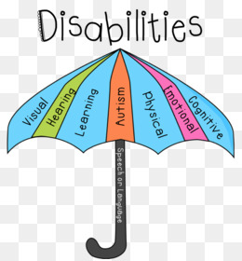

**KENYA INSTITUTE OF SPECIAL EDUCATION (ORGANIZATIONS OFFERING SERVICES FOR THE DISABLED)**

To facilitate service provision for persons with special needs and disabilities through human capital development, research, functional assessment, rehabilitation, Inclusive education practices, technology and production of learning and assistive materials

Kasarani/Mwiki Road, off Thika Road, next to ICIPE

P.O.Box 48413, Nairobi

Tel: 020-8007977,

Cell: 0725-607978, 0734-801860

info@kise.co.ke



**LOCAL SHELTER/SHELTER OF HOPE**

Shelter of hope Centre is a nonprofit making organization registered under the societies act. We have the call and responsibility to reach out to the children and youths who are orphans and destitute by providing spiritual confidence to enable them be part of the achievement in the society.

Childcare - Youth Shelters - Counseling Physical Health - Education - Meals - Employment

Buru Buru Business Complex, Next To Kenya National Library, 2nd Flr, Rm 32

(+254) 20 2664664

http://shelterofhopekenya.or.ke

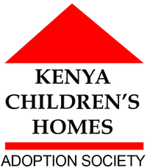

**KENYA CHILDREN’S HOME**

Through Kenya Children’s Homes and our associated projects, we help around 1700 children in Kenya every year. We have a committed team of 200 Kenyan staff including teachers, house mothers, management and social workers, all of whom have the single goal of providing the best care, protection and education to the children we help.

Childcare Youth Shelters Meals Education Clothing

P.O. Box 44261-00100, Langata Road, Nairobi, Kenya

00254 2060 02002

http://www.kenyachildrenshomes.org.uk



**FOOD BANK/S**

Reducing food wastage, alleviate hunger, enhance the sustainability of the vulnerable through sourcing and distribution of food to enhance self-sustaining income-generating activities.

Food Banking Kenya

P.O Box: 966 – 00517

Nairobi, Kenya

Call Us on: +254 714 963 809

Email: info@foodbankingkenya.org

[Kenya@foodbank.co](mailto:Kenya@foodbank.co)

[**octopizzofoundation.org**](http://www.octopizzofoundation.org/)

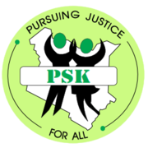

**AIDS LAW PROJECT (LEGAL SERVICES)**

To provide quality, efficient and coordinated paralegal services through training, legal aid, dispute resolution and policy advocacy in Kenya.

Hazina Towers Wing A Monrovia Street, 13th Floor, Door 3

P.O. Box 4045- 00200 Nairobi

Tel: 020-2219718

Fax: 020-342471

info@aidslawproject.org

infoaidslawproject@gmail.com